Subject name:
subject code: WEDE5020
NAMES: THAGWANA ZWAVHUDI
STUDENT NO: ST10481009

Project Proposals
THAGWIS AI MECHANIC & Green Earth Community Foundation

Table of Contents
Introduction 3
1. THAGWIS AI MECHANIC - Proposal Summary 3
1.1 Organisation Overview 3
1.2 Website Goals and Target Audience 3
1.3 Current Website Analysis 3
1.4 Proposed Features and Design 4
1.5 Technical Requirements, Timeline and Budget 4
2. Green Earth Community Foundation - Proposal Summary 5
2.1 Organisation Overview 5
2.2 Website Goals and Target Audience 5
2.3 Current Website Analysis 5
2.4 Proposed Features and Design 5
2.5 Technical Requirements, Timeline and Budget 6
3. Reference List 7

Introduction
This document presents condensed, summaries of two website development project proposals: THAGWIS AI MECHANIC, an automotive technology workshop, and the Green Earth Community Foundation (GECF), a community environmental non-profit. Each summary retains the core structure of the original proposal organisational background, website goals and audience, current-state analysis, proposed features and design, and technical, timeline and budget considerations.
This document is the first of two companion documents. The research methodology and source-evaluation approach used to compile both proposals are presented separately in the accompanying Content Research and Sourcing document.

1. THAGWIS AI MECHANIC - Proposal

1.1 Organisation Overview
THAGWIS AI MECHANIC is a proposed South African automotive workshop that combines skilled technicians with AI-powered diagnostic tools to service vehicles fitted with advanced electronic, artificial intelligence (AI) and electric vehicle (EV) systems. Its mission is to deliver innovative, reliable and affordable repair and maintenance solutions, with a vision of becoming South Africa's leading AI-powered automotive workshop. This reflects a wider industry shift, as AI-assisted diagnostics and smart vehicle systems are increasingly reshaping automotive repair and the technical skills it demands across South Africa (Audatex South Africa, 2025).
- Core services: AI-powered diagnostics, EV maintenance, brake and suspension repairs, battery testing and fleet servicing.
- Business objectives: build an online presence, raise awareness of AI-powered servicing, and improve customer communication.

1.2 Website Goals and Target Audience
As the organisation is still in its planning stage, a professional website is required to establish credibility, inform customers and generate service enquiries. The primary audience comprises individual owners of petrol, hybrid, EV and AI-assisted vehicles, while the secondary audience includes fleet operators, dealerships and insurers who require ongoing diagnostic and maintenance support.

1.3 Current Website Analysis
THAGWIS AI MECHANIC has no existing website, so a SWOT analysis was used to guide planning:
- Strengths: establishes a professional, semantic HTML5 presence that improves accessibility and maintainability (World Wide Web Consortium (W3C), 2024).
- Weaknesses: booking and payment functionality are not yet available.
- Opportunities: scope to add CSS, JavaScript, online booking and digital marketing in later phases (Laudon and Laudon, 2023).
- Threats: competition from established repair businesses and rising cybersecurity risk as interactive features are added.

1.4 Proposed Features and Design
The website will comprise five linked pages - Home, About Us, Services, Enquiry and Contact - accessed through a consistent navigation menu, as illustrated in Figure 1. Semantic HTML5 elements such as <header>, <nav>, <main> and <footer> will support accessibility and search engine optimisation (Duckett, 2011). The visual design follows a dark-blue, white, silver and red palette set in Arial and Calibri typography, guided by usability principles that prioritise intuitive navigation and efficient task completion (Krug, 2014).
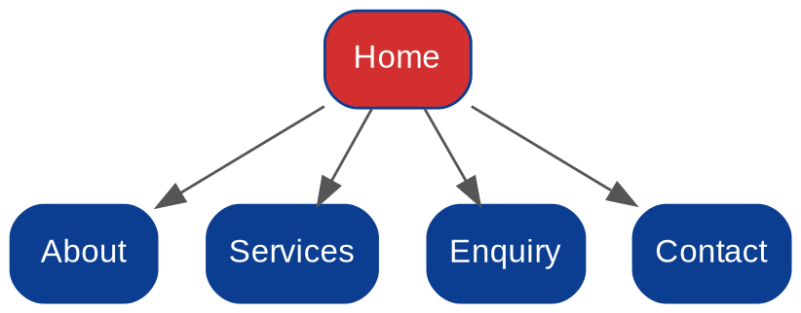
Figure 1: Proposed site structure for the THAGWIS AI MECHANIC website (own diagram, 2026).

1.5 Technical Requirements, Timeline and Budget
Part 1 of the project will be developed in HTML5, with CSS, JavaScript, an online booking system and database integration planned for future phases. A structured six-week schedule, summarised below, supports effective project control (Satzinger, Jackson and Burd, 2016):
- Week 1 - Project planning and proposal approval.
- Week 2 - Research and requirements gathering.
- Week 3 - Website planning and wireframes.
- Week 4 - HTML website development.
- Week 5 - Testing and quality assurance.
- Week 6 - Documentation and final submission.
The estimated budget totals R12 350, covering domain registration, hosting, logo design, stock images and development labour; free tools such as Visual Studio Code help to minimise costs.

2. Green Earth Community Foundation - Proposal Summary

2.1 Organisation Overview
The Green Earth Community Foundation (GECF) is a proposed non-profit organisation promoting environmental sustainability, conservation and community development across South Africa through awareness campaigns, tree-planting, recycling initiatives and community clean-ups. Its mission is to educate, inspire and empower communities to protect the environment, with a vision of becoming a leading community-based environmental organisation. This mirrors a broader shift among South African non-profits toward digital tools that improve operational efficiency and strengthen stakeholder engagement (Trialogue Knowledge Hub, 2025).
- Core services: environmental awareness campaigns, clean-up initiatives, recycling education, school programmes and volunteer coordination.
- Business objectives: increase public awareness, recruit volunteers, and build partnerships with schools, businesses and local government.

2.2 Website Goals and Target Audience
A website is needed to share programme information, recruit volunteers and strengthen stakeholder communication. The primary audience includes community members, learners, students and prospective volunteers, while the secondary audience comprises schools, municipalities, NGOs and corporate social responsibility (CSR) partners (Laudon and Laudon, 2023).

2.3 Current Website Analysis
As GECF has no existing website, a SWOT analysis informed the plan:
- Strengths: a professional identity built on accessible, semantic HTML5 (World Wide Web Consortium (W3C), 2024).
- Weaknesses: an HTML-only build limits interactivity, with no automated confirmations or online donations yet.
- Opportunities: growth in volunteer participation, partnerships and future fundraising features (Trialogue Knowledge Hub, 2025).
- Threats: competition from larger, established environmental organisations and limited maintenance funding (Krug, 2014).

2.4 Proposed Features and Design
The website will include Home, About Us, Projects, Volunteer Registration and Contact pages linked by consistent navigation, as illustrated in Figure 2. A volunteer-registration HTML form will collect contact details, preferred activities and availability. Semantic elements such as <header>, <nav>, <article> and <footer> will improve accessibility and search engine optimisation (Duckett, 2011). The design uses a nature-inspired palette of forest green, white, light green and brown, set in Arial and Calibri fonts to create a clear typographic hierarchy (Krug, 2014).
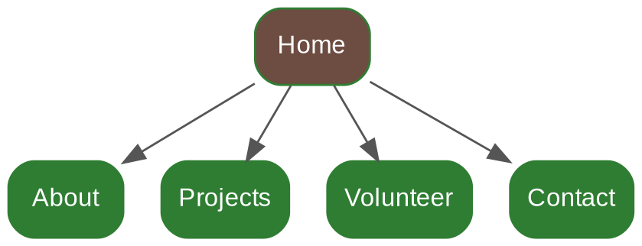
Figure 2: Proposed site structure for the Green Earth Community Foundation website (own diagram, 2026).

2.5 Technical Requirements, Timeline and Budget
Part 1 will be developed in HTML5, with CSS, JavaScript, online donations and event registration earmarked for later phases. The six-week schedule below follows recognised project-management principles (Satzinger, Jackson and Burd, 2016):
- Week 1 - Proposal and planning approved.
- Week 2 - Requirements gathering completed.
- Week 3 - Website structure and wireframes completed.
- Week 4 - HTML website development completed.
- Week 5 - Website testing completed.
- Week 6 - Documentation and final submission.
The estimated budget totals R11 450, covering domain registration, hosting, logo design, environmental imagery and development labour, using free development tools to keep costs low (Laudon and Laudon, 2023).

3. Reference List
Google (2026) Google Fonts. Available at: Google Fonts (Accessed: 12 August 2026).

Google (2026) Google Fonts Developer Guide. Available at: Google Fonts Developer Guide (Accessed: 12 August 2026).

Mozilla Developer Network (MDN) (2026) HTML: HyperText Markup Language. Available at: MDN HTML documentation (Accessed: 12 August 2026).

Mozilla Developer Network (MDN) (2026) HTML forms guide. Available at: MDN HTML forms guide (Accessed: 12 August 2026).

Pixabay (2026) Content License Summary. Available at: Pixabay Content License (Accessed: 12 August 2026).

Pixabay (2026) Terms of Service. Available at: Pixabay Terms of Service (Accessed: 12 August 2026).

Unsplash (2025) Can I use Unsplash images for personal or commercial projects? Available at: Unsplash Help Center (Accessed: 12 August 2026).

Unsplash (2025) Do I have to give credit to a contributor when I use their image? Available at: Unsplash Help Center (Accessed: 12 August 2026).

Unsplash (2026) What if there is a brand or logo in an image on Unsplash? Available at: Unsplash Help Center (Accessed: 12 August 2026).

World Wide Web Consortium (W3C) (2026) HTML Standard. Available at: W3C HTML Standard (Accessed: 12 August 2026).

World Wide Web Consortium (W3C) (2026) Web Accessibility Initiative. Available at: W3C Web Accessibility Initiative (Accessed: 12 August 2026).

